# Use case 008 – Post a chirp as user

Description

An unauthenticated user logs in the system as user, he or she goes to his or her chirps, once there he or she publishes a chirp.

Access

Login > **Username:** user1; **Password:** user1 > User functions dropdown > Your chirps > “Create new chirp” button.

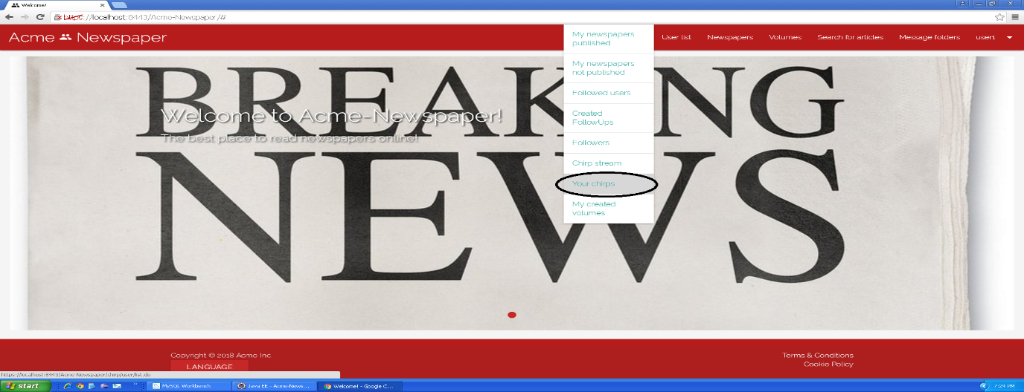

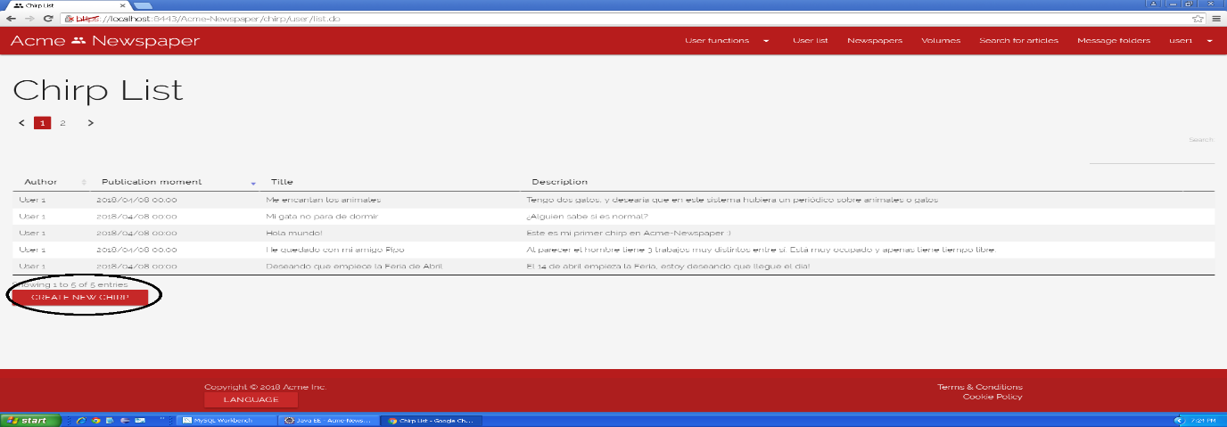

Tests

|  |  |
| --- | --- |
| **Test <#001>** | |
| **Description** | Once you are in the create chirp view, you press the cancel button. |
| **Expected** | The system must redirect you to your chirp list view. |
| **Outcome** | The outcome is the one expected. When pressing the cancel button, my chirp list is shown. |
| **Notes** |  |

|  |  |
| --- | --- |
| **Test <#002>** | |
| **Description** | Once you are in the create chirp view, you press the save button without data in any field. |
| **Expected** | The system must redirect you to the same view (create chirp) but showing validation messages in fields. |
| **Outcome** | The outcome is the one expected. Validation messages appear in the fields. |
| **Notes** |  |

|  |  |
| --- | --- |
| **Test <#003>** | |
| **Description** | Once you are in the create newspaper view, you press the save button inserting the following data: **Title: “**<script>alarm('Hacked!'); </script>”, **Description:** “This is a test”. |
| **Expected** | The system must redirect you to the same view (create chirp) but showing “Insecure HTML” validation error. |
| **Outcome** | The outcome is the one expected. The “Insecure HTML” validation error appears. |
| **Notes** |  |

|  |  |
| --- | --- |
| **Test <#004>** | |
| **Description** | Once you are in the create chirp view, you press the save button inserting the following data: **Title:** “Chirp test”, **Description:** “This is just a test, don’t worry”. |
| **Expected** | The system must redirect you to your chirp list view which will show the new chirp. |
| **Outcome** | The outcome is the one expected. The chirp that has just been created appears in the list of my chirps. However, the message below the list says: “Showing 1 to 5 of 5 entries”, but there are 3 pages of Chirps, so there are more than 5 entries (at least, 11).    The Chirps can’t be ordered between all the list, only the 5 that appear in the first table. |
| **Notes** |  |

|  |  |
| --- | --- |
| **Test <#005>** | |
| **Description** | Before doing any other thing, you must set the webpage language to “Spanish”, then, once you are in the create chirp view, you press the “Cancelar” button. |
| **Expected** | The system must redirect you to your chirp list view. |
| **Outcome** | The outcome is the one expected. When pressing the cancel button, my chirp list is shown. |
| **Notes** |  |

|  |  |
| --- | --- |
| **Test <#006>** | |
| **Description** | Before doing any other thing, you must set the webpage language to “Spanish”, then, once you are in the create chirp view, you press the “Guardar” button without data in any field. |
| **Expected** | The system must redirect you to the same view (create chirp) but showing validation messages in fields. |
| **Outcome** | The outcome is the one expected. Validation messages appear in the fields. |
| **Notes** |  |

|  |  |
| --- | --- |
| **Test <#007>** | |
| **Description** | Before doing any other thing, you must set the webpage language to “Spanish”, then, once you are in the create newspaper view, you press the “Guardar” button inserting the following data: **Título: “**<script>alarm('Hacked!'); </script>”, **Descripción:** “This is a test”. |
| **Expected** | The system must redirect you to the same view (create chirp) but showing “HTML inseguro” validation error. |
| **Outcome** | The outcome is the one expected. The “Insecure HTML” validation error appears. |
| **Notes** |  |

|  |  |
| --- | --- |
| **Test <#008>** | |
| **Description** | Before doing any other thing, you must set the webpage language to “Spanish”, then, once you are in the create chirp view, you press the “Guardar” button inserting the following data: **Título:** “Chirp test”, **Descripción:** “This is just a test, don’t worry”. |
| **Expected** | The system must redirect you to your chirp list view which will show the new chirp. |
| **Outcome** | The outcome is the one expected. The chirp that has just been created appears in the list of my chirps. However, along the bugs listed in the same test above when run in English, the system language is set to Spanish, but the phrase below the list is in English. |
| **Notes** |  |

# Use case 012 – Display a stream with the chirps of the followed users

Description

An authenticated user goes to the chirp stream to see the chirps posted by the users he or she follows.

Access

Login > **Username:** user1; **Password:** user1 > User functions dropdown > Chirp stream.

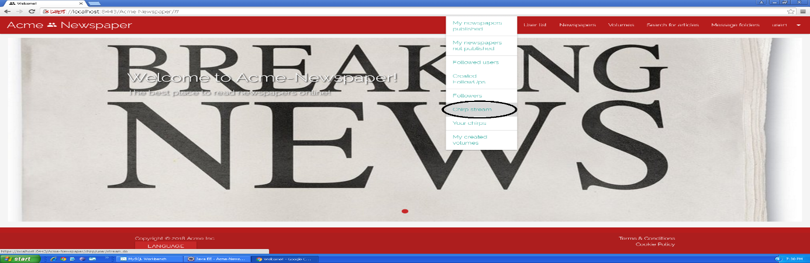

Tests

|  |  |
| --- | --- |
| **Test <#001>** | |
| **Description** | Once “Chirp stream” button is pressed, you get into the chirp list view. |
| **Expected** | You must be redirected to the stream of chirps, where you can see 2 pages and 5 chirps written by “User 2” sorted by publication moment. |
| **Outcome** | The outcome is the one expected. The list is shown with all the chirps from user 2. However, the message below the list states: “Showing 1 to 5 of 5 entries” which is not correct, because there are 6 entries. |
| **Notes** | Tester note: This bug also exists in the “Your Chirps” view |

|  |  |
| --- | --- |
| **Test <#002>** | |
| **Description** | Once “Chirp stream” button is pressed, you get into the chirp list view and press the button to the second page. |
| **Expected** | You must be redirected to the second page of the list, which only has a chirp. |
| **Outcome** | The outcome is the one expected, but the message below the table in the second page states: “Showing 1 to 1 of 1 entries”, which is incorrect, it should be “Showing 6 to 6 of 6 entries” |
| **Notes** | Tester note: This bug also exists in the “Your Chirps” view |

|  |  |
| --- | --- |
| **Test <#003>** | |
| **Description** | Once “Chirp stream” button is pressed, you get into the chirp list view and press the button to sort any of its attributes. |
| **Expected** | You must see chirps sorted by the clicked attribute. |
| **Outcome** | The outcome was not the expected. The list cannot be ordered correctly: Only the chirps that are currently in the list can be ordered, but not all of them at once. |
| **Notes** | Tester note: This bug also exists in the “Your Chirps” view |

|  |  |
| --- | --- |
| **Test <#004>** | |
| **Description** | Before doing any other thing, you must set the webpage language to “Spanish”, then, once “Lista de chirps” button is pressed, you get into the chirp list view. |
| **Expected** | You must be redirected to the stream of chirps, where you can see 2 pages and 5 chirps written by “User 2” sorted by publication moment. |
| **Outcome** | The outcome is the one expected. The list is shown with all the chirps from user 2. However, along the bug stated in the test run in English, the message below the list is in English, although the language is set to Spanish |
| **Notes** | Tester note: This bug also exists in the “Tus Chirps” view |

|  |  |
| --- | --- |
| **Test <#005>** | |
| **Description** | Before doing any other thing, you must set the webpage language to “Spanish”, then, once “Lista de chirps” button is pressed, you get into the chirp list view and press the button to the second page. |
| **Expected** | You must be redirected to the second page of the list, which only has a chirp. |
| **Outcome** | The outcome is the one expected, but the message below the table in the second page states: “Showing 1 to 1 of 1 entries”, which is incorrect, it should be “Showing 6 to 6 of 6 entries” |
| **Notes** | Tester note: This bug also exists in the “Tus Chirps” view |

|  |  |
| --- | --- |
| **Test <#006>** | |
| **Description** | Before doing any other thing, you must set the webpage language to “Spanish”, then, once “Lista de chirps” button is pressed, you get into the chirp list view and press the button to sort any of its attributes. |
| **Expected** | You must see chirps sorted by the clicked attribute. |
| **Outcome** | The outcome was not the expected. The list cannot be ordered correctly: Only the chirps that are currently in the list can be ordered, but not all of them at once. |
| **Notes** | Tester note: This bug also exists in the “Tus Chirps” view |

# Use case 013 – Register as an agent

Description

An unauthenticated user goes to the register as an agent view and fills the form, once the form is filled, he or she presses the register button.

Access

Main Menu > Register in the system > Register as agent.

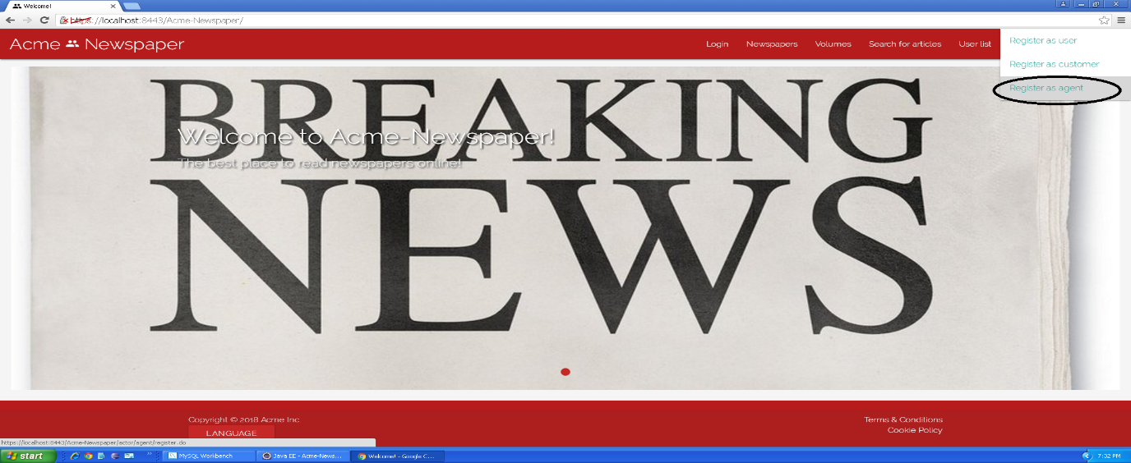

Tests

|  |  |
| --- | --- |
| **Test <#001>** | |
| **Description** | The form must be filled in with the following data: **Name:** ‘Bond’; **Surname:** ’James Bond’; **Phone number:** ‘634634007’; **Postal address:** ‘007 Avocado Street, Iowa’; **Email:** ‘bondja@007.com’; **Birthdate:** ’07/07/1987’ **Username:** ‘bondja’; **Password:** ‘bondja’; **Confirm password:** ‘bondja’. You must also accept **Terms & Conditions**. |
| **Expected** | At the end of the use case, the system must redirect you to the main view. |
| **Outcome** | The outcome is the one expected. The system creates the new agent and returns to the main view. |
| **Notes** |  |

|  |  |
| --- | --- |
| **Test <#002>** | |
| **Description** | The form must be blank, only the “I accept Terms & Conditions” box must be checked, otherwise the “Register” button will be inaccessible. |
| **Expected** | At the end of the use case, the system must redirect you to the same form, but each field must have its validation error. |
| **Outcome** | The outcome is the one expected. Validation messages appear in the fields. |
| **Notes** |  |

|  |  |
| --- | --- |
| **Test <#003>** | |
| **Description** | Once you access the form, you must press the “Cancel” button. |
| **Expected** | You must be redirected to main view. |
| **Outcome** | The outcome is the one expected. When pressing the cancel button, the main view is shown. |
| **Notes** | In this test field content can be both filled or blank. |

|  |  |
| --- | --- |
| **Test <#004>** | |
| **Description** | The form must be filled in with the following data: **Name:** ‘<script>alarm('Hacked!'); </script>’; **Surname:** ’James Bond’; **Phone number:** ‘634634007’; **Postal address:** ‘007 Avocado Street, Iowa’; **Email:** ‘bondja@007.com’; **Birthdate:** ’07/07/1987’ **Username:** ‘bondja’; **Password:** ‘bondja’; **Confirm password:** ‘bondja’. You must also accept **Terms & Conditions**. |
| **Expected** | At the end of the use case, the system must redirect you to the register user form with an error message in “Name” field where you can read “Insecure HTML” |
| **Outcome** | The outcome is the one expected. The “Insecure HTML” validation error appears. |
| **Notes** |  |

|  |  |
| --- | --- |
| **Test <#005>** | |
| **Description** | Before accessing the form, language must be set to “Spanish”, after this, the form must be filled in with the following data: **Nombre:** ‘Bond’; **Apellidos:** ’James Bond’; **Número de teléfono:** ‘634634007’; **Dirección:** ‘007 Avocado Street, Iowa’; **Correo electrónico:** ‘bondja@007.com’; **Fecha de nacimiento:** ’07/07/1987’ **Nombre de usuario:** ‘bondja’; **Contraseña:** ‘bondja’; **Confirmar contraseña:** ‘bondja’. You must also accept **Términos y Condiciones**. |
| **Expected** | At the end of the use case, the system must redirect you to the main view. |
| **Outcome** |  |
| **Notes** |  |

|  |  |
| --- | --- |
| **Test <#006>** | |
| **Description** | Before accessing the form, language must be set to “Spanish”, after this, the form must be blank, only the “Acepto los términos y condiciones” box must be checked, otherwise the “Registrarse” button will be inaccessible. |
| **Expected** | At the end of the use case, the system must redirect you to the same form, but each field must have its validation error. |
| **Outcome** | The outcome is the one expected. Validation messages appear in the fields. |
| **Notes** |  |

|  |  |
| --- | --- |
| **Test <#007>** | |
| **Description** | Before accessing the form, language must be set to “Spanish”, after this, once you access the form, you must press the “Cancelar” button. |
| **Expected** | You must be redirected to main view. |
| **Outcome** | The outcome is the one expected. When pressing the cancel button, the main view is shown. |
| **Notes** | In this test field content can be both filled or blank. |

|  |  |
| --- | --- |
| **Test <#008>** | |
| **Description** | Before accessing the form, language must be set to “Spanish”, after this, the form must be filled in with the following data: **Nombre:** ‘<script>alarm('Hacked!'); </script>’; **Apellidos:** ’James Bond’; **Número de teléfono:** ‘634634007’; **Dirección:** ‘007 Avocado Street, Iowa’; **Correo electrónico:** ‘bondja@007.com’; **Fecha de nacimiento:** ’07/07/1987’ **Nombre de usuario:** ‘bondja’; **Contraseña:** ‘bondja’; **Confirmar contraseña:** ‘bondja’. You must also accept **Términos y Condiciones**. |
| **Expected** | At the end of the use case, the system must redirect you to the register user form with an error message in “Nombre” field where you can read “HTML inseguro” |
| **Outcome** | The outcome is the one expected. The “Insecure HTML” validation error appears. |
| **Notes** |  |

# Use case 014 – Create advertisement

Description

An unauthenticated user logs in the system as an agent, he or she goes to his or her advertisements, once there he or she creates an advertisement.

Access

Login > **Username:** agent1; **Password:** agent1 > Agent functions dropdown > My advertisements > “Create” button.

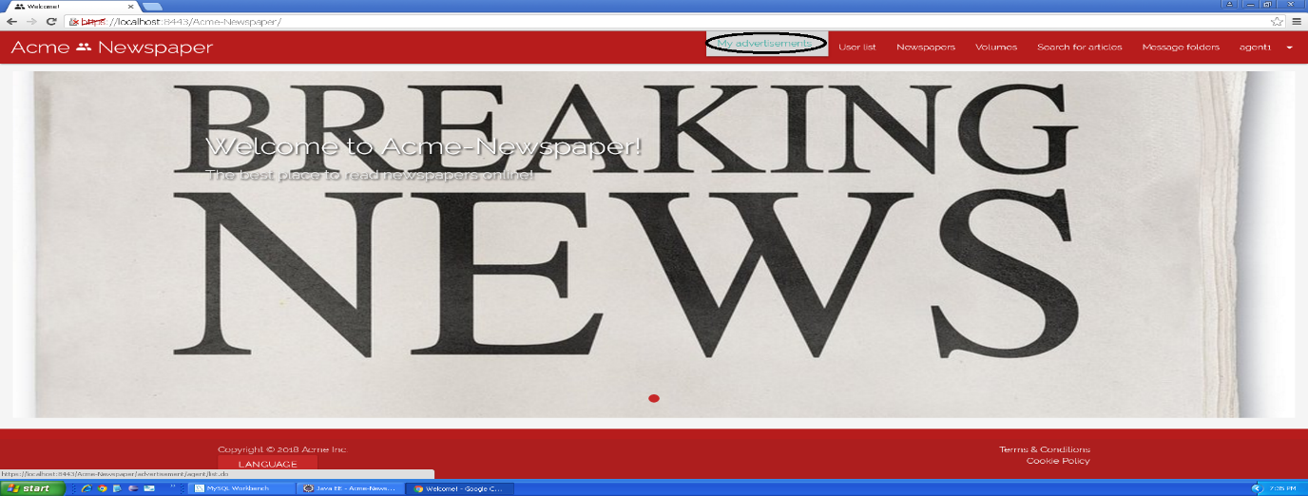

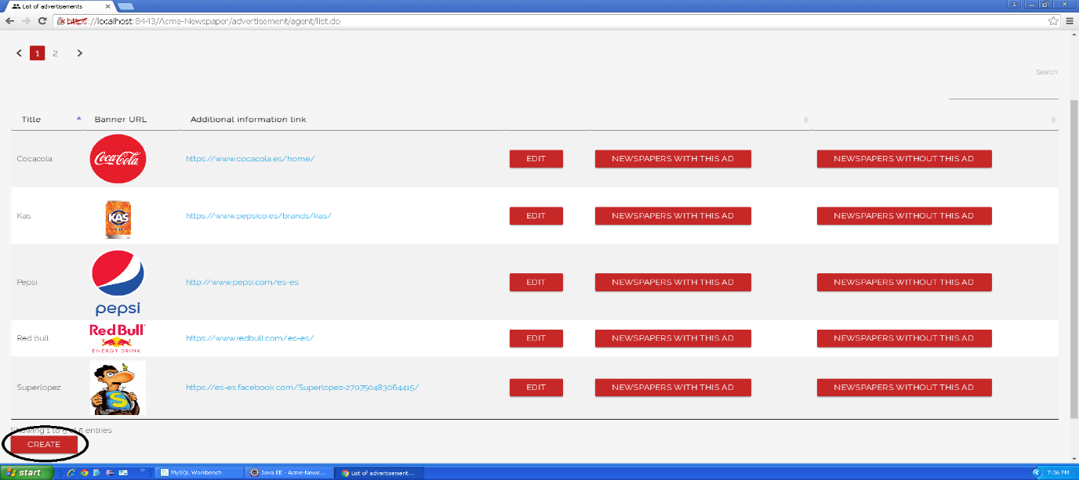

Tests

|  |  |
| --- | --- |
| **Test <#001>** | |
| **Description** | Once you are in the create advertisement view, you press the cancel button. |
| **Expected** | The system must redirect you to your advertisement list view. |
| **Outcome** | The outcome is the one expected. When pressing the cancel button, the list of my advertisements is shown. |
| **Notes** |  |

|  |  |
| --- | --- |
| **Test <#002>** | |
| **Description** | Once you are in the create advertisement view, you press the save button without data in any field. |
| **Expected** | The system must redirect you to the same view (create advertisement) but showing validation messages in fields. |
| **Outcome** | The outcome is the one expected. Validation messages appear in the fields. |
| **Notes** |  |

|  |  |
| --- | --- |
| **Test <#003>** | |
| **Description** | Once you are in the create newspaper view, you press the save button inserting the following data: **Title: “**<script>alarm('Hacked!'); </script>”, **Banner url:** “https://test.jpg”, **Additional info link:** “https://test.com”, **Holder name:** “Agent test” **Brand name:** “Test”, **Number:** “1111111111111117”, **Expiration month:** “7”, **Expiration year:** “18”, **CVV:** “123”. |
| **Expected** | The system must redirect you to the same view (create advertisement) but showing “Insecure HTML” validation error. |
| **Outcome** | The outcome is the one expected. The “Insecure HTML” validation error appears. |
| **Notes** | Tester note: This test says: “create newspaper view” |

|  |  |
| --- | --- |
| **Test <#004>** | |
| **Description** | Once you are in the create newspaper view, you press the save button inserting the following data: **Title: “**Test”, **Banner url:** “https://test.jpg”, **Additional info link:** “https://test.com”, **Holder name:** “Agent test” **Brand name:** “Test”, **Number:** “1111111111111117”, **Expiration month:** “6”, **Expiration year:** “18”, **CVV:** “123”. |
| **Expected** | The system must redirect you to the same view (create advertisement) but showing “The credit card must not be expired” validation error. |
| **Outcome** | The outcome is not the one expected. The system allowed to create the advertisement. |
| **Notes** | Tester notes:  - The expiration month meant to be tested is not in the past, so the system should allow the creation of this advertisement.  - This test says: “create newspaper view” |

|  |  |
| --- | --- |
| **Test <#005>** | |
| **Description** | Once you are in the create chirp view, you press the save button inserting the following data: **Title: “**Test”, **Banner url:** “https://test.jpg”, **Additional info link:** “https://test.com”, **Holder name:** “Agent test” **Brand name:** “Test”, **Number:** “1111111111111117”, **Expiration month:** “10”, **Expiration year:** “18”, **CVV:** “123”. |
| **Expected** | The system must redirect you to your advertisement list view which will show the new advertisement. |
| **Outcome** | The outcome is the one expected. The system allowed to create the advertisement and returned to the advertisements list |
| **Notes** | Tester note: This test says: “create chirp view”. |

|  |  |
| --- | --- |
| **Test <#006>** | |
| **Description** | Once you are in the newspaper list view, you press the “details” button in the first newspaper, in the detailed view you press the “add an ad to this newspaper” button, it will redirect you to the advertisements list view, in the first row, you must click on “use” button. |
| **Expected** | The system must redirect you to your advertisement list view but the button “use” now is “don’t use this ad”. |
| **Outcome** | The outcome is the one expected. The button besides the ad that I used appears. |
| **Notes** | Tester notes:  - The Ad I created in the previous test, which is the one I used for this test, was not in the first row, it was in the second page of advertisements.  - The ad in the first row was already in use for that newspaper, so it was impossible to see the “use this ad” button. |

|  |  |
| --- | --- |
| **Test <#007>** | |
| **Description** | Before doing any other thing, you must set the webpage language to “Spanish”, then, once you are in the create advertisement view, you press the “Cancelar” button. |
| **Expected** | The system must redirect you to your advertisement list view. |
| **Outcome** | The outcome is the one expected. When pressing the cancel button, the list of my advertisements is shown. |
| **Notes** |  |

|  |  |
| --- | --- |
| **Test <#008>** | |
| **Description** | Before doing any other thing, you must set the webpage language to “Spanish”, then, once you are in the create advertisement view, you press the “Guardar” button without data in any field. |
| **Expected** | The system must redirect you to the same view (create advertisement) but showing validation messages in fields. |
| **Outcome** | The outcome is the one expected. When pressing the cancel button, the list of my advertisements is shown. |
| **Notes** |  |
| **Test <#009>** | |
| **Description** | Before doing any other thing, you must set the webpage language to “Spanish”, then, once you are in the create newspaper view, you press the “Guardar” button inserting the following data: **Título: “T**est”**Imagen:** “https://test.jpg”, **Hipervículo de información adicional:** “https://test.com”, **Nombre del portador:** “Agent test” **Nombre de la marca:** “Test”, **Número:** “1111111111111117”, **Mes de caducidad:** “6”, **Año de caducidad:** “18”, **CVV:** “123 |
| **Expected** | The system must redirect you to the same view (create advertisement) but showing “La tarjeta de crédito no debe estar caducada” validation error. |
| **Outcome** | The outcome is not the one expected. The system allowed to create the advertisement. |
| **Notes** | Tester note:  - The expiration month meant to be tested is not in the past, so the system should allow the creation of this advertisement.  - This test says: “create newspaper view” |

|  |  |
| --- | --- |
| **Test <#010>** | |
| **Description** | Before doing any other thing, you must set the webpage language to “Spanish”, then, once you are in the create newspaper view, you press the “Guardar” button *inserting the following data:* ***Título: “****<script>alarm('Hacked!'); </script>”,* ***Imagen:*** *“https://test.jpg”,* ***Hipervículo de información adicional:*** *“https://test.com”,* ***Nombre del portador:*** *“Agent test”* ***Nombre de la marca:*** *“Test”,* ***Número:*** *“1111111111111117*”, **Mes de caducidad:** “7”, **Año de caducidad:** “18”, **CVV:** “123 |
| **Expected** | The system must redirect you to the same view (create advertisement) but showing “HTML inseguro” validation error. |
| **Outcome** | The outcome is the one expected. The “Insecure HTML” validation error appears. |
| **Notes** | Tester note: This test says: “create newspaper view” |

|  |  |
| --- | --- |
| **Test <#011>** | |
| **Description** | Once you are in the create chirp view, you press the save button inserting the following data: **Título: “**test**”, Imagen: “**https://test.jpg**”, Hipervículo de información adicional: “**https://test.com**”, Nombre del portador: “**Agent test**” Nombre de la marca: “**Test**”, Número: “**1111111111111117**”, Mes de caducidad: “**7**”, Año de caducidad: “**18**”, CVV: “**123”. |
| **Expected** | The system must redirect you to your advertisement list view which will show the new advertisement. |
| **Outcome** | The outcome is the one expected. The system allowed to create the advertisement and returned to the advertisements list |
| **Notes** | Tester note: This test says: “create chirp view” |

|  |  |
| --- | --- |
| **Test <#012>** | |
| **Description** | Before doing any other thing, you must set the webpage language to “Spanish”, then, once you are in the newspaper list view, you press the “detalles” button in the first newspaper, in the detailed view you press the “Poner un anuncio a este periódico” button, it will redirect you to the advertisements list view, in the first row, you must click on “usar” button. |
| **Expected** | The system must redirect you to your advertisement list view but the button “usar” now is “no usar”. |
| **Outcome** | The outcome is the one expected. The button besides the ad that I used appears. |
| **Notes** | Tester notes:  - The Ad I created in the previous test, which is the one I used for this test, was not in the first row, it was in the second page of advertisements.  - The ad in the first row was already in use for that newspaper, so it was impossible to see the “use this ad” button. |

# Use case 017 – Remove an article

Description

An authenticated administrator goes to article list and delete an article that he or she things is unappropriated.

Access

Main menu > Search for articles

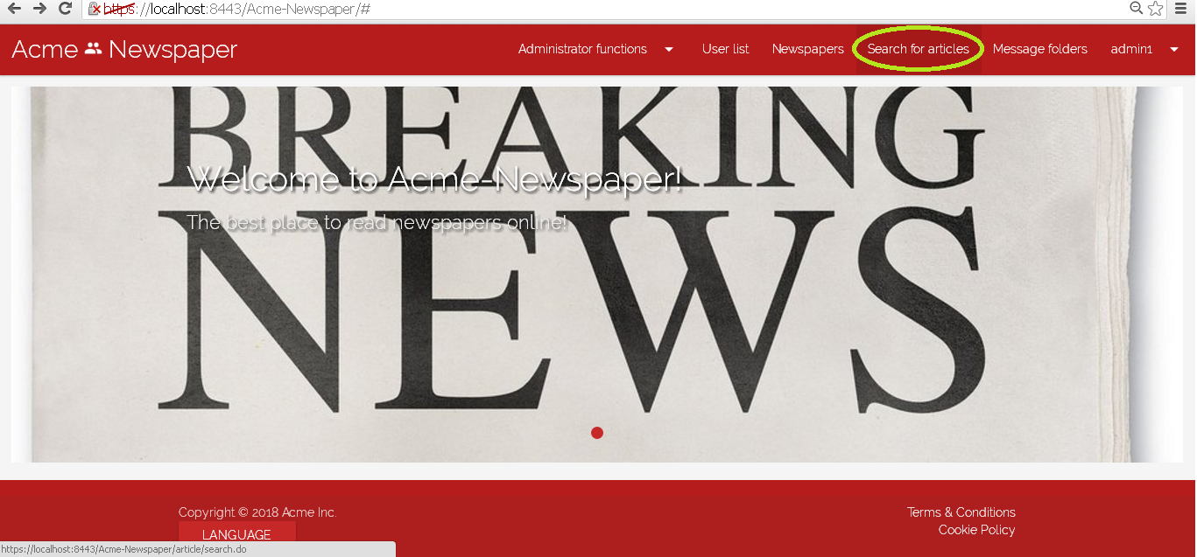

Tests

|  |  |
| --- | --- |
| **Test <#001>** | |
| **Description** | You must log in the system like “admin1” introducing in login view “admin1” like user name and “admin1” like password.    Then press in main menu the option “Search for articles”, you must be redirected to article list, now to press the button delete in the first article of the list and you will delete it. |
| **Expected** | You must be redirected to the detailed view of the newspaper called “El informático”, the article deleted belonged to that newspaper, so you can see that now this article not appear in newspaper’s article list. Also, you can go to the view “Search for articles” and prove that the article does not appear there either. |
| **Outcome** | The outcome is the one expected. The page redirected to the newspaper that owned the article, and the articles’ list doesn’t contain the deleted article. |
| **Notes** |  |

|  |  |
| --- | --- |
| **Test <#002>** | |
| **Description** | Now before test that use case you must set language to “Spanish”.  You must log in the system like “admin1” introducing in login view “admin1” like user name and “admin1” like password.    Then press in main menu the option “Búsqueda de artículos”, you must be redirected to article list, now to press the button delete in the first article of the list and you will delete it. |
| **Expected** | You must be redirected to the detailed view of the newspaper called “Nessie”, the article deleted belonged to that newspaper, so you can see that now this article not appear in newspaper’s article list. Also, you can go to the view “Búsqueda de artículos” and prove that the article does not appear there either. |
| **Outcome** | The outcome is not the one expected. The page redirected to the newspaper that owned the article, and the articles’ list doesn’t contain the deleted article, but the newspaper is not the one expected in the test. |
| **Notes** | Tester note: In my version of the project, the articles’ list only contains 2 pages of articles, which differs from the screenshot, that shows 3 pages. |

# Use case 018 – Remove an unappropriated newspaper

Description

An authenticated administrator goes to newspaper list and delete a newspaper that he or she things is unappropriated. Remove a newspaper, implies removing all the articles of which it is composed.

Access

Main menu > Newspapers

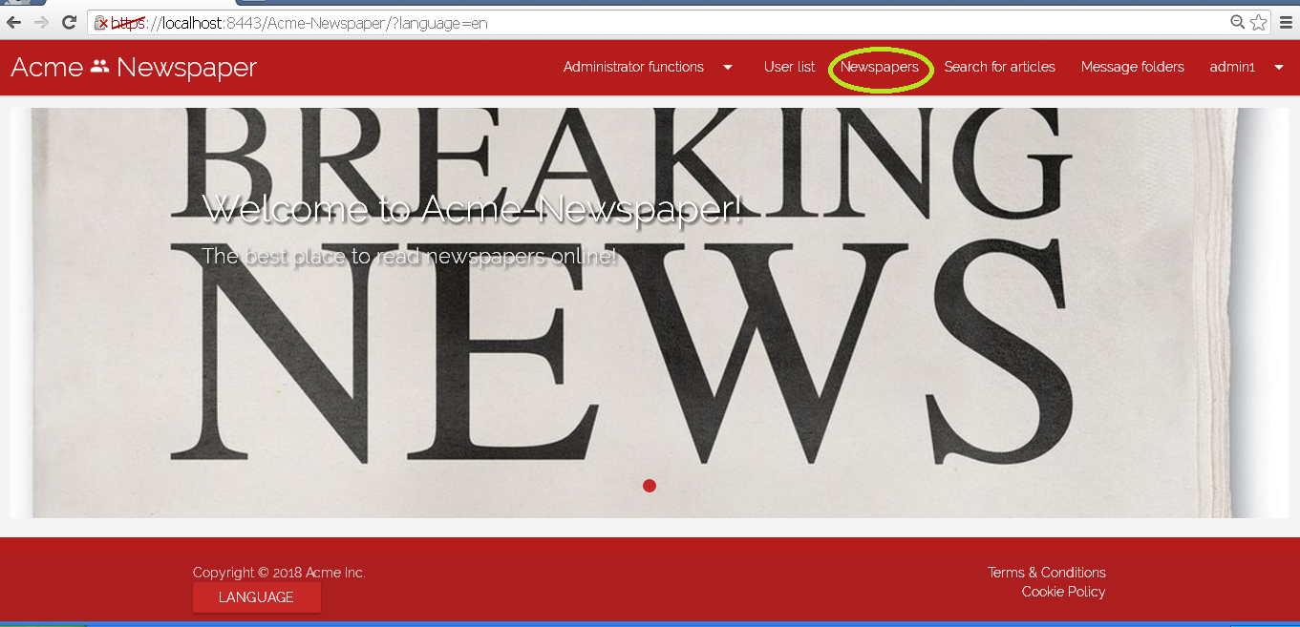

Tests

|  |  |
| --- | --- |
| **Test <#001>** | |
| **Description** | You must log in the system like “admin1” introducing in login view “admin1” like user name and “admin1” like password.    Then press in main menu the option “Newspaper”, you must be redirected to newspaper list, now to press the button delete in the second newspaper of the list, called “The big pizza”, that has only an article titled “Come hasta que no puedas mas!”, press delete button to clean it. |
| **Expected** | You must be redirected to the newspaper list view again, but like you can see the newspaper not appear. It has been deleted no the system, his articles have been deleted too, you can prove it going to “Search for articles” in the nav menu and searching for the article with the bowser tool. |
| **Outcome** | The outcome is, at least, half the one expected. The page redirected to the newspaper list and the deleted newspaper does not appear anymore. However, the articles’ list doesn’t show the requested article before deleting the newspaper, so it is impossible to test that the article has been correctly removed. |
| **Notes** | Tester note: The newspaper called “The big pizza” does not appear in the 2nd position, but the 3rd. |

|  |  |
| --- | --- |
| **Test <#002>** | |
| **Description** | Now before test that use case you must set language to “Spanish”.  You must log in the system like “admin1” introducing in login view “admin1” like user name and “admin1” like password.    Then press in main menu the option “Periódicos”, you must be redirected to newspaper list, now to press the button delete in the second newspaper of the list, called “The big pizza”, that has only an article titled “Come hasta que no puedas mas!”, press delete button to clean it. |
| **Expected** | You must be redirected to the newspaper list view again, but like you can see the newspaper not appear. It has been deleted no the system, his articles have been deleted too, you can prove it going to “Búsqueda de artículos” in the nav menu and searching for the article with the bowser tool. |
| **Outcome** | The outcome is, at least, half the one expected. The page redirected to the newspaper list and the deleted newspaper does not appear anymore. However, the articles’ list doesn’t show the requested article before deleting the newspaper, so it is impossible to test that the article has been correctly removed. |
| **Notes** | Tester note: To delete the same newspaper I was asked, I had to re-populate the database, which is not indicated anywhere. Also, the newspaper was in the 3rd position again, not the 2nd. |

# Use case 020 – Manage a list of taboo words

Description

An authenticated administrator can manage a list of taboo words to the system.

Access

Main menu > Administrator Functions > Configuration

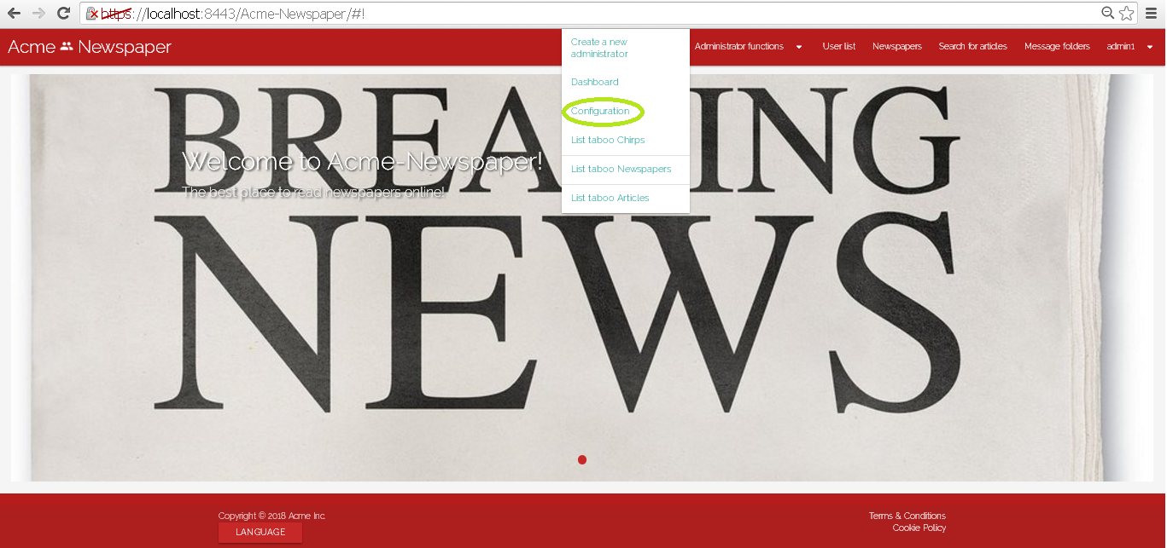

Tests

|  |  |
| --- | --- |
| **Test <#001>** | |
| **Description** | You must log in the system like “admin1” introducing in login view “admin1” like user name and “admin1” like password.    Then press in main menu the option “Administrator functions”, and in the select menu press the option “Configuration”. The you will see a view with the actual configuration, press “edit”.    Now you will be redirected to a form view where you can edit taboo words, when try to change or add some taboo word and they will be update pressing the button “save”. |
| **Expected** | You must be redirected to Configuration view, with the new taboo words saved. |
| **Outcome** | The outcome is the one expected. The taboo word has been correctly saved and appears in the configuration view. |
| **Notes** | Tester note: There is no hint on how to create new taboo words in the form, regarding the pattern. |
| **Test <#002>** | |
| **Description** | Now before test that use case you must set language to “Spanish”.  You must log in the system like “admin1” introducing in login view “admin1” like user name and “admin1” like password.    Then press in main menu the option “Funciones de administrador”, and in the select menu press the option “Configuración”. The you will see a view with the actual configuration, press “editar”.    Now you will be redirected to a form view where you can edit taboo words, when try to change or add some taboo word and they will be update pressing the button “guardar”. |
| **Expected** | You must be redirected to Configuration view, with the new taboo words saved. |
| **Outcome** | The outcome is the one expected. The taboo word has been correctly saved and appears in the configuration view. |
| **Notes** | Tester note: There is no hint on how to create new taboo words in the form, regarding the pattern. |

# Use case 021 – List the articles that contain taboo words

Description

An authenticated administrator can list articles that contain taboo words.

Access

Main menu > Administrator Functions > List Taboo Articles

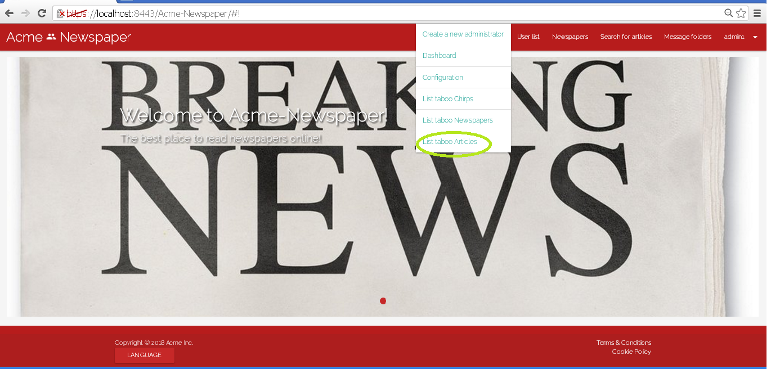

Tests

|  |  |
| --- | --- |
| **Test <#001>** | |
| **Description** | You must log in the system like “admin1” introducing in login view “admin1” like user name and “admin1” like password.    Then press in main menu the option “Administrator functions”, and in the select menu press the option “List taboo articles”. |
| **Expected** | You must be redirected to taboo article list. |
| **Outcome** | The outcome is the one expected. The list of articles with taboo words appears. |
| **Notes** |  |

|  |  |
| --- | --- |
| **Test <#002>** | |
| **Description** | Now before test that use case you must set language to “Spanish”.  You must log in the system like “admin1” introducing in login view “admin1” like user name and “admin1” like password.    Then press in main menu the option “Funciones de administrador”, and in the select menu press the option “Listar Artículos tabú”. |
| **Expected** | You must be redirected to taboo article list. |
| **Outcome** | The outcome is the one expected. The list of articles with taboo words appears. |
| **Notes** |  |

# Use case 023 – List the newspapers that contain taboo words

Description

An authenticated administrator can list newspapers that contain taboo words.

Access

Main menu > Administrator Functions > List taboo Newspapers

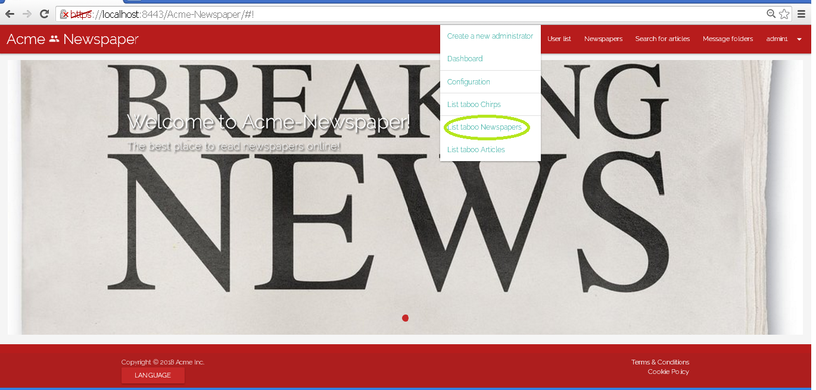

Tests

|  |  |
| --- | --- |
| **Test <#001>** | |
| **Description** | You must log in the system like “admin1” introducing in login view “admin1” like user name and “admin1” like password.    Then press in main menu the option “Administrator functions”, and in the select menu press the option “List taboo newspapers”. |
| **Expected** | You must be redirected to taboo newspaper list. |
| **Outcome** | The outcome is the one expected. The list of newspapers with taboo words appears. |
| **Notes** |  |

|  |  |
| --- | --- |
| **Test <#002>** | |
| **Description** | Now before test that use case you must set language to “Spanish”.  You must log in the system like “admin1” introducing in login view “admin1” like user name and “admin1” like password.    Then press in main menu the option “Funciones de administrador”, and in the select menu press the option “Listar Periódicos tabú”. |
| **Expected** | You must be redirected to taboo newspaper list. |
| **Outcome** | The outcome is the one expected. The list of newspapers with taboo words appears. |
| **Notes** |  |

# Use case 024 – List advertisements containing taboo words in its title

Description

An authenticated administrator can list the advertisements that contain taboo words in its title.

Access

Main menu > Administrator Functions > List taboo advertisements

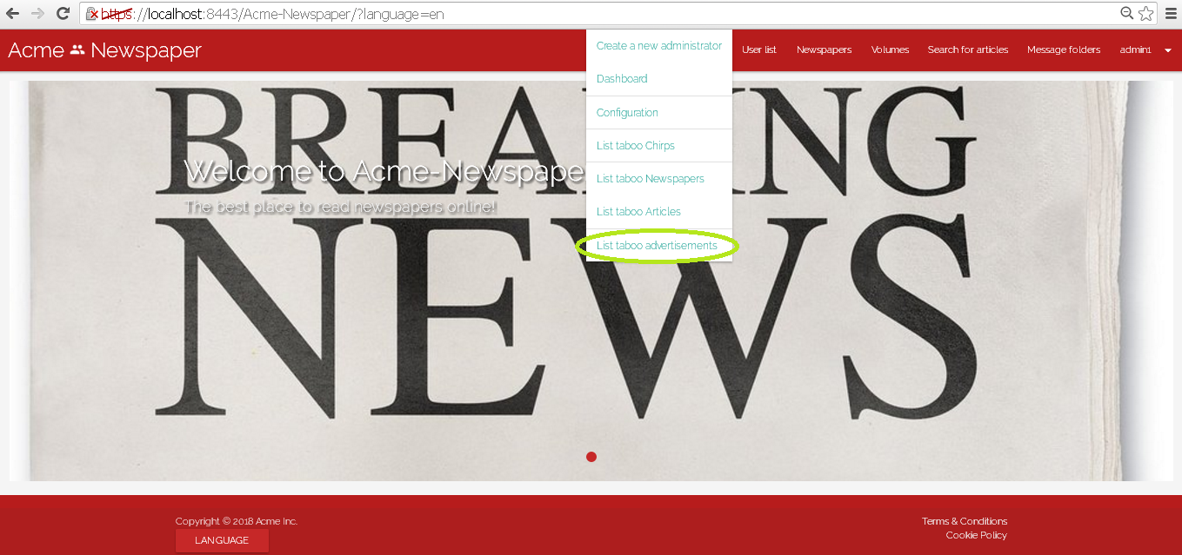

Tests

|  |  |
| --- | --- |
| **Test <#001>** | |
| **Description** | You must log in the system like “admin1” introducing in login view “admin1” like user name and “admin1” like password.    Then press in main menu the option “Administrator functions”, and in the select menu press the option “List taboo advertisements”. |
| **Expected** | You must be redirected to taboo advertisement list. |
| **Outcome** | The outcome is the one expected. The list of advertisements with taboo words appears. |
| **Notes** |  |

|  |  |
| --- | --- |
| **Test <#002>** | |
| **Description** | Now before test that use case you must set language to “Spanish”.  You must log in the system like “admin1” introducing in login view “admin1” like user name and “admin1” like password.    Then press in main menu the option “Funciones de administrador”, and in the select menu press the option “Listar anuncios tabú”. |
| **Expected** | You must be redirected to taboo advertisement list. |
| **Outcome** | The outcome is the one expected. The list of advertisements with taboo words appears. |
| **Notes** |  |

# Use case 025 – Remove an unappropriated advertisement

Description

An authenticated administrator goes to advertisement list and delete an advertisement that he or she things is unappropriated.

Access

Main menu > Advertisement

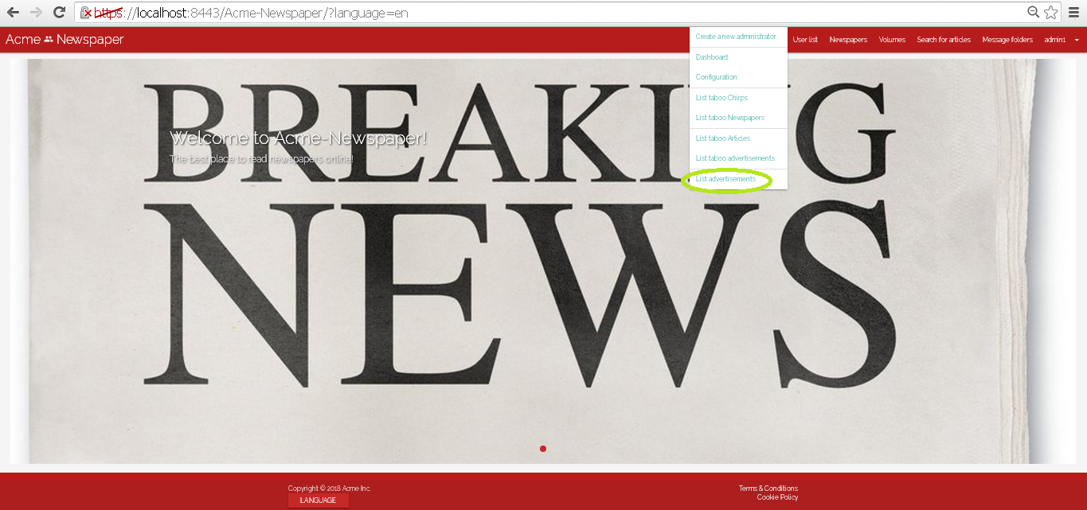

Tests

|  |  |
| --- | --- |
| **Test <#001>** | |
| **Description** | You must log in the system like “admin1” introducing in login view “admin1” like user name and “admin1” like password.    Then press in main menu “Administrator functions/List advertisement” you must be redirected to advertisement list, now to press the button delete in the first advertisement of the list and you will be deleted it. |
| **Expected** | You must be redirected to Taboo advertisement list, that is other view when you can delete advertisement in the same way. |
| **Outcome** | The outcome is the one expected. The list of advertisements with taboo words appears. |
| **Notes** |  |

|  |  |
| --- | --- |
| **Test <#002>** | |
| **Description** | Now before test that use case you must set language to “Spanish”.  You must log in the system like “admin1” introducing in login view “admin1” like user name and “admin1” like password.    Then press in main menu “Funciones de Administrador /Lista de anuncios” you must be redirected to advertisement list, now to press the button “borrar” in the first advertisement of the list and you will be deleted it. |
| **Expected** | You must be redirected to Taboo advertisement list, that is other view when you can delete advertisement in the same way. |
| **Outcome** | The outcome is the one expected. The list of advertisements with taboo words appears. |
| **Notes** | Tester note: The advertisement I was meant to delete was already deleted in the previous test, so I had to delete another one. |

# Use case 027 – Remove an unappropriated chirp

Description

An authenticated administrator removes a chirp that he or she thinks its unappropriated.

Access

Main menu > User List > Display User

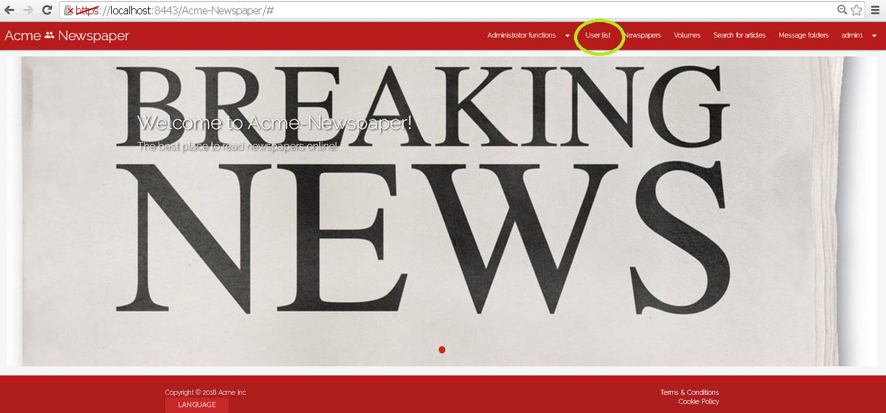

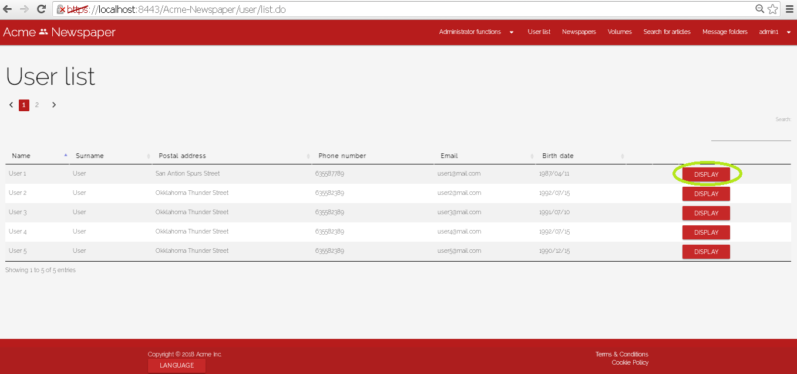

Tests

|  |  |
| --- | --- |
| **Test <#001>** | |
| **Description** | You must log in the system like “admin1” introducing in login view “admin1” like user name and “admin1” like password.    Go to “User List” and press display in the first user, now you must be redirected to the profile of that user, go a little down and you will see the created chirps list of the user selected, press delete in the first one and you will be deleted it. |
| **Expected** | At the end of the use case you must be redirected to the taboo chirp list. |
| **Outcome** | The outcome is the one expected. The list of chirps with taboo words appears. |
| **Notes** |  |

|  |  |
| --- | --- |
| **Test <#002>** | |
| **Description** | Now before test that use case you must set language to “Spanish”.  You must log in the system like “admin1” introducing in login view “admin1” like user name and “admin1” like password.    Go to “User List” and press display in the first user, now you must be redirected to the profile of that user, go a little down and you will see the created chirps list of the user selected, press delete in the first one and you will be deleted it. |
| **Expected** | At the end of the use case you must be redirected to the taboo chirp list. |
| **Outcome** | The outcome is the one expected. The list of chirps with taboo words appears. |
| **Notes** |  |

# Use case 028 – List the chirps that contain taboo words

Description

An authenticated administrator can list chirps that contain taboo words.

Access

Main menu > Administrator Functions > List taboo Chirps

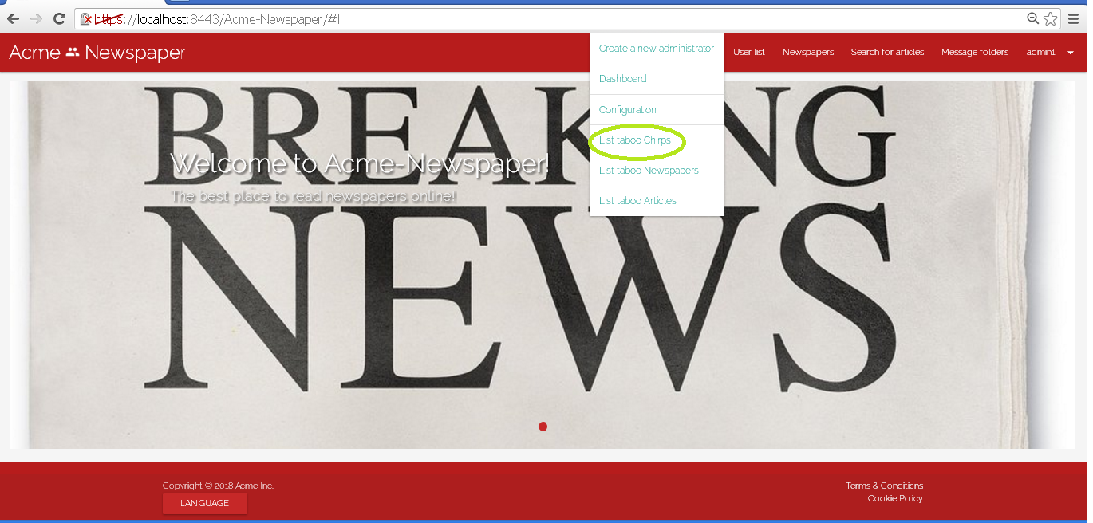

Tests

|  |  |
| --- | --- |
| **Test <#001>** | |
| **Description** | You must log in the system like “admin1” introducing in login view “admin1” like user name and “admin1” like password.    Then press in main menu the option “Administrator functions”, and in the select menu press the option “List taboo chirps”. |
| **Expected** | You must be redirected to taboo chirps list. |
| **Outcome** | The outcome is the one expected. The list of chirps with taboo words appears. |
| **Notes** |  |

|  |  |
| --- | --- |
| **Test <#002>** | |
| **Description** | Now before test that use case you must set language to “Spanish”.  You must log in the system like “admin1” introducing in login view “admin1” like user name and “admin1” like password.    Then press in main menu the option “Funciones de administrador”, and in the select menu press the option “Listar Chirps tabú”. |
| **Expected** | You must be redirected to taboo chirps list. |
| **Outcome** | The outcome is the one expected. The list of articles with taboo words appears. |
| **Notes** |  |

# Use case 031 – Register as a customer

Description

An unauthenticated goes to the register view and fills the form, once the form is filled, he or she presses the register as customer button.

Access

Main Menu > Register as customer.

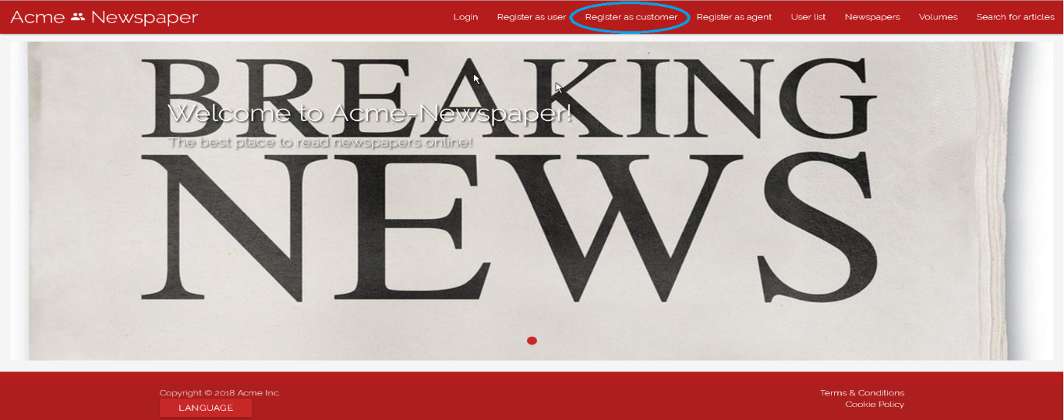

Tests

|  |  |
| --- | --- |
| **Test <#001>** | |
| **Description** | The form must be filled in with the following data: **Name:** ‘Juan’; **Surname:** ’David Pérez’; **Phone number:** ‘650353637’; **Postal address:** ‘123 Walk Street, USA’; **Email:** ’[juanda@gmail.com](mailto:juanda@gmail.com)’; **Birthdate:** ’16/04/1996’ **Username:** ‘juanda’; **Password:** ‘davidjuan’; **Confirm password:** ‘davidjuan’. You must also accept **Terms & Conditions**. |
| **Expected** | At the end of the use case, the system must redirect you to the main view. |
| **Outcome** | The outcome is the one expected. The system creates the new agent and returns to the main view. |
| **Notes** | Tester note: The button to register as a customer is not where the screenshot shows, it’s elsewhere. |

|  |  |
| --- | --- |
| **Test <#002>** | |
| **Description** | The form must be blank, only check the “I accept Terms & Conditions” box, otherwise the “Register” button will be inaccessible. |
| **Expected** | At the end of the use case, the system must redirect you to the same form to register a customer, but each field must have its validation error. |
| **Outcome** | The outcome is the one expected. Validation messages appear in the fields. |
| **Notes** |  |

|  |  |
| --- | --- |
| **Test <#003>** | |
| **Description** | Once you access the form, you must press the “Cancel” button. |
| **Expected** | You must be redirected to main view. |
| **Outcome** | The outcome is the one expected. When pressing the cancel button, the main view is shown. |
| **Notes** | In this test, fields content can be both filled or blank. |

|  |  |
| --- | --- |
| **Test <#004>** | |
| **Description** | The form must be filled in with the following data: **Name:** ‘Juan’; **Surname:** ’David Pérez’; **Phone number:** ‘650353637’; **Postal address:** ‘<script>alarm('Hacked!'); </script>’; **Email:** ’[juanda@gmail.com](mailto:juanda@gmail.com)’; **Birthdate:** ’16/04/1996’ **Username:** ‘juanda’; **Password:** ‘davidjuan’; **Confirm password:** ‘davidjuan’. You must also accept **Terms & Conditions**. |
| **Expected** | At the end of the use case, the system must redirect you to the register customer form with an error message in “Postal Address” field where you can read “Insecure HTML” |
| **Outcome** | The outcome is the one expected. The “Insecure HTML” validation error appears. |
| **Notes** |  |

|  |  |
| --- | --- |
| **Test <#005>** | |
| **Description** | Before accessing the form, language must be set to “Spanish”, after this, the form must be filled in with the following data: **Name:** ‘Juan’; **Surname:** ’David Pérez’; **Phone number:** ‘650353637’; **Postal address:** ‘123 Walk Street, USA’; **Email:** ’[juanda@gmail.com](mailto:juanda@gmail.com)’; **Birthdate:** ’16/04/1996’ **Username:** ‘juanda’; **Password:** ‘davidjuan’; **Confirm password:** ‘davidjuan’. You must also accept **Terms & Conditions** |
| **Expected** | At the end of the use case, the system must redirect you to the main view. |
| **Outcome** | The outcome is not the one expected. The system remains in the same form, along a message that says: “El usuario ya existe”, and the customer is not created. |
| **Notes** |  |